**移动设备开发-实验作业#1-5(合并提交)**

**请同学完成作业后，**以word**档案方式提供给学习委员**

**档案的主题格式必须严格遵守如下所示，否则扣分:**

**[Android] [班级][学号][姓名][实验作业#1-5].docx (注意:”[]”括号符号不能省略)**

**例如: [Android][21大数据1][** **202124114343][王大明][实验作业#1-5].docx (doc也可)**

**实验作业缴交截止日: 2024/4/30**

**实验作业#1:** 编制一个"我的故乡"图册，下方配有说明文字，单击"上一张""下一张"按钮，图片切换时说明文字也随之切换，且"上一张""下一张"按钮的下方显示前一张及后一张的图片缩略图，如下图，图1所示。

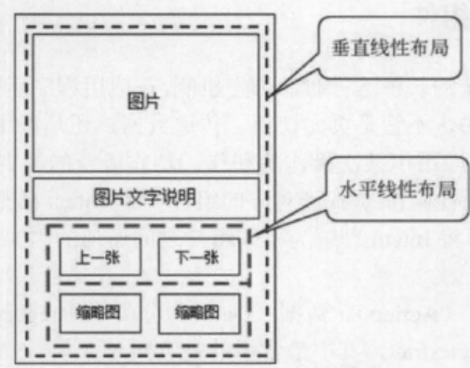

图1 浏览图片及缩赂图

请将设计好之用户使用之GUI页面截图，并提供用户GUI页面的xml档案内容(activity_main.xml的代码)。

**实验结果:**

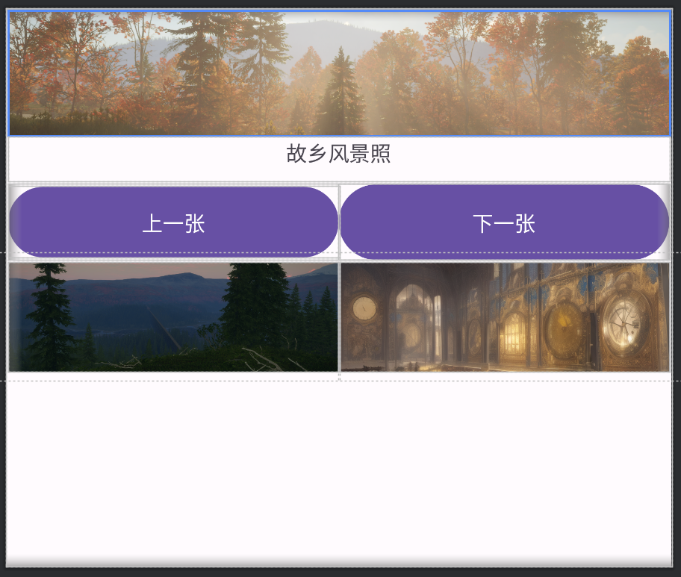

<?xml version="1.0" encoding="utf-8"?>  
<LinearLayout  
 xmlns:android="http://schemas.android.com/apk/res/android"  
 android:layout_width="match_parent"  
 android:layout_height="match_parent"  
 android:orientation="vertical"  
 android:padding="16dp">  
  
 <!-- 主图片展示 -->  
 <ImageView  
 android:id="@+id/main_image"  
 android:layout_width="match_parent"  
 android:layout_height="955dp"  
 android:scaleType="centerCrop"  
 android:src="@drawable/a" />  
  
 <!-- 图片说明文字 -->  
  
 <!-- 控制按钮区域 -->  
 <TextView  
 android:id="@+id/image_caption"  
 android:layout_width="match_parent"  
 android:layout_height="341dp"  
 android:layout_marginTop="8dp"  
 android:text="故乡风景照"  
 android:textAlignment="center"  
 android:textSize="160sp" />  
  
 <LinearLayout  
 android:layout_width="match_parent"  
 android:layout_height="wrap_content"  
 android:layout_marginTop="16dp"  
 android:orientation="horizontal"  
 android:gravity="center">  
  
 <Button  
 android:id="@+id/btn_previous"  
 android:layout_width="wrap_content"  
 android:layout_height="545dp"  
 android:layout_weight="1"  
 android:textSize="160sp"  
 android:text="上一张" />  
  
 <Button  
 android:id="@+id/btn_next"  
 android:layout_width="wrap_content"  
 android:layout_height="582dp"  
 android:layout_weight="1"  
 android:textSize="160sp"  
 android:text="下一张" />  
 </LinearLayout>  
  
 <!-- 缩略图预览区域 -->  
 <LinearLayout  
 android:layout_width="match_parent"  
 android:layout_height="832dp"  
 android:layout_marginTop="16dp"  
 android:gravity="center"  
 android:orientation="horizontal">  
  
 <ImageView  
 android:id="@+id/thumbnail_prev"  
 android:layout_width="80dp"  
 android:layout_height="80dp"  
 android:layout_margin="4dp"  
 android:src="@drawable/b"  
 android:scaleType="centerCrop" />  
  
 <ImageView  
 android:id="@+id/thumbnail_next"  
 android:layout_width="80dp"  
 android:layout_height="80dp"  
 android:layout_margin="4dp"  
 android:src="@drawable/c"  
 android:scaleType="centerCrop" />  
 </LinearLayout>  
  
</LinearLayout>

**实验作业#2:** 设计一个具有两个页面的程序，**第1 个页面**显示一张封面的图片、文字(TextView)、文字编辑框(EditText)，并设计一个按钮能够跳转第2个页面。

再者，在**第2 个页面**除了显示”欢迎进入第二页面”之外，还要能够显示第一个页面所输入的文字编辑框的内容，而且还要设计一个按钮，能够跳回第一个页面，以达到这两个页面之间能够相互切换。

请将设计好之用户使用之GUI页面截图，并提供用户GUI页面的xml档案内容与java编程。此外执行结果也须提供。

**实验结果:**

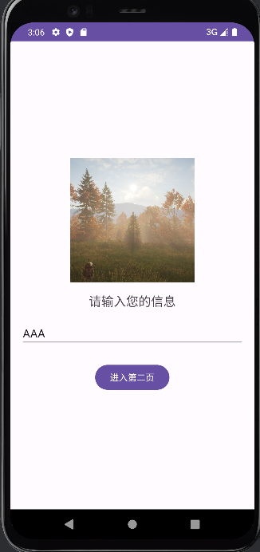 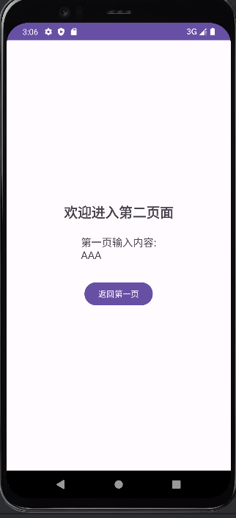

**activity_main.xml**

<?xml version="1.0" encoding="utf-8"?>  
<LinearLayout  
 xmlns:android="http://schemas.android.com/apk/res/android"  
 android:layout_width="match_parent"  
 android:layout_height="match_parent"  
 android:orientation="vertical"  
 android:padding="16dp"  
 android:gravity="center">  
  
 <!-- 封面图片 -->  
 <ImageView  
 android:layout_width="200dp"  
 android:layout_height="200dp"  
 android:src="@drawable/a"  
 android:scaleType="centerCrop"/>  
  
 <!-- 文字说明 -->  
 <TextView  
 android:layout_width="wrap_content"  
 android:layout_height="wrap_content"  
 android:text="请输入您的信息"  
 android:textSize="20sp"  
 android:layout_marginTop="16dp"/>  
  
 <!-- 文字输入框 -->  
 <EditText  
 android:id="@+id/et_input"  
 android:layout_width="match_parent"  
 android:layout_height="wrap_content"  
 android:hint="输入内容..."  
 android:layout_marginTop="16dp"/>  
  
 <!-- 跳转按钮 -->  
 <Button  
 android:id="@+id/btn_go_to_second"  
 android:layout_width="wrap_content"  
 android:layout_height="wrap_content"  
 android:text="进入第二页"  
 android:layout_marginTop="24dp"/>  
  
</LinearLayout>

**activity_second.xml**

<?xml version="1.0" encoding="utf-8"?>

<LinearLayout

xmlns:android="http://schemas.android.com/apk/res/android"

android:layout_width="match_parent"

android:layout_height="match_parent"

android:orientation="vertical"

android:padding="16dp"

android:gravity="center">

<!-- 欢迎文字 -->

<TextView

android:layout_width="wrap_content"

android:layout_height="wrap_content"

android:text="欢迎进入第二页面"

android:textSize="24sp"

android:textStyle="bold"/>

<!-- 显示输入内容 -->

<TextView

android:id="@+id/tv_display"

android:layout_width="wrap_content"

android:layout_height="wrap_content"

android:layout_marginTop="24dp"

android:textSize="18sp"/>

<!-- 返回按钮 -->

<Button

android:id="@+id/btn_back"

android:layout_width="wrap_content"

android:layout_height="wrap_content"

android:text="返回第一页"

android:layout_marginTop="32dp"/>

</LinearLayout>

**MainActivity.java**

package com.example.myapplication;  
  
import android.content.Intent;  
import android.os.Bundle;  
import android.widget.Button;  
import android.widget.EditText;  
  
import androidx.activity.EdgeToEdge;  
import androidx.appcompat.app.AppCompatActivity;  
import androidx.core.graphics.Insets;  
import androidx.core.view.ViewCompat;  
import androidx.core.view.WindowInsetsCompat;  
  
public class MainActivity extends AppCompatActivity {  
 private EditText etInput;  
  
 @Override  
 protected void onCreate(Bundle savedInstanceState) {  
 super.onCreate(savedInstanceState);  
 setContentView(R.layout.*activity_main*);  
  
 etInput = findViewById(R.id.*et_input*);  
 Button btnGoToSecond = findViewById(R.id.*btn_go_to_second*);  
  
 // 跳转按钮点击事件  
 btnGoToSecond.setOnClickListener(v -> {  
 String inputText = etInput.getText().toString();  
  
 // 创建Intent并传递数据  
 Intent intent = new Intent(MainActivity.this, SecondActivity.class);  
 intent.putExtra("USER_INPUT", inputText);  
 startActivity(intent);  
 });  
 }  
}

**SecondActivity.java**

package com.example.myapplication;  
  
import android.os.Bundle;  
import android.widget.Button;  
import android.widget.TextView;  
  
import androidx.appcompat.app.AppCompatActivity;  
  
public class SecondActivity extends AppCompatActivity {  
 @Override  
 protected void onCreate(Bundle savedInstanceState) {  
 super.onCreate(savedInstanceState);  
 setContentView(R.layout.*activity_second*);  
  
 // 获取传递的数据  
 String userInput = getIntent().getStringExtra("USER_INPUT");  
  
 // 显示输入内容  
 TextView tvDisplay = findViewById(R.id.*tv_display*);  
 tvDisplay.setText("第一页输入内容:\n" + userInput);  
  
 // 返回按钮点击事件  
 Button btnBack = findViewById(R.id.*btn_back*);  
 btnBack.setOnClickListener(v -> finish()); // 关闭当前页面  
 }  
}

**执行结果：**

2025-04-23 22:55:31: Launching app on 'Pixel 4 API 31'.

Starting: Intent { act=android.intent.action.MAIN cat=[android.intent.category.LAUNCHER] cmp=com.example.myapplication/.MainActivity }

Open logcat panel for emulator Pixel 4 API 31

Connected to process 5971 on device 'Pixel_4_API_31 [emulator-5554]'.

**实验作业#3:** 设计一个可以移动的小球(球的图形中间是一个更小的四方形)，当小球被拖到一个小矩形块中时，则退出程序。

请将设计好之用户使用之GUI页面截图，并提供用户GUI页面的xml档案内容与java编程。此外执行结果也须提供。

**实验结果:**



**MainACtivity.java**

package com.example.work3;  
  
import android.os.Bundle;  
import androidx.appcompat.app.AppCompatActivity;  
  
  
public class MainActivity extends AppCompatActivity {  
 @Override  
 protected void onCreate(Bundle savedInstanceState) {  
 super.onCreate(savedInstanceState);  
 setContentView(R.layout.*activity_main*);  
 }  
}

**DraggableBallView.java**

package com.example.work3;  
  
import android.app.Activity;  
import android.content.Context;  
import android.graphics.Canvas;  
import android.graphics.Color;  
import android.graphics.Paint;  
import android.graphics.Rect;  
import android.util.AttributeSet;  
import android.view.MotionEvent;  
import android.view.View;  
  
public class DraggableBallView extends View {  
 private static final int *BALL_RADIUS* = 50;  
 private static final int *SQUARE_SIZE* = 20;  
 private float ballX = 300, ballY = 300;  
 private boolean isDragging = false;  
 private Rect targetRect;  
  
 public DraggableBallView(Context context) {  
 super(context);  
 init();  
 }  
  
 public DraggableBallView(Context context, AttributeSet attrs) {  
 super(context, attrs);  
 init();  
 }  
  
 public DraggableBallView(Context context, AttributeSet attrs, int defStyleAttr) {  
 super(context, attrs, defStyleAttr);  
 init();  
 }  
  
 // 初始化目标矩形坐标（需在布局完成后获取）  
 private void init() {  
 post(() -> {  
 View target = ((Activity)getContext()).findViewById(R.id.*target_rect*);  
 if (target != null) { // 空值检查  
 int[] loc = new int[2];  
 target.getLocationOnScreen(loc);  
 targetRect = new Rect(  
 loc[0], loc[1],  
 loc[0] + target.getWidth(),  
 loc[1] + target.getHeight()  
 );  
 }  
 });  
 }  
  
 @Override  
 protected void onDraw(Canvas canvas) {  
 super.onDraw(canvas);  
 // 绘制蓝色小球  
 Paint ballPaint = new Paint();  
 ballPaint.setColor(Color.*BLUE*);  
 canvas.drawCircle(ballX, ballY, *BALL_RADIUS*, ballPaint);  
  
 // 绘制白色中心方块  
 Paint squarePaint = new Paint();  
 squarePaint.setColor(Color.*WHITE*);  
 canvas.drawRect(  
 ballX - *SQUARE_SIZE*/2f,  
 ballY - *SQUARE_SIZE*/2f,  
 ballX + *SQUARE_SIZE*/2f,  
 ballY + *SQUARE_SIZE*/2f,  
 squarePaint  
 );  
 }  
  
 @Override  
 public boolean onTouchEvent(MotionEvent event) {  
 switch (event.getAction()) {  
 case MotionEvent.*ACTION_DOWN*:  
 // 检测触摸点是否在小球范围内  
 if (isInBall(event.getX(), event.getY())) {  
 isDragging = true;  
 }  
 return true;  
  
 case MotionEvent.*ACTION_MOVE*:  
 if (isDragging) {  
 // 更新小球位置  
 ballX = event.getX();  
 ballY = event.getY();  
 checkCollision();  
 invalidate();  
 }  
 return true;  
  
 case MotionEvent.*ACTION_UP*:  
 isDragging = false;  
 return true;  
 }  
 return super.onTouchEvent(event);  
 }  
  
 // 碰撞检测  
 private void checkCollision() {  
 if (targetRect == null) return;  
  
 Rect ballArea = new Rect(  
 (int)(ballX - *BALL_RADIUS*),  
 (int)(ballY - *BALL_RADIUS*),  
 (int)(ballX + *BALL_RADIUS*),  
 (int)(ballY + *BALL_RADIUS*)  
 );  
  
 if (Rect.*intersects*(ballArea, targetRect)) {  
 ((Activity)getContext()).finish();  
 }  
 }  
  
 // 判断触摸点是否在球内  
 private boolean isInBall(float x, float y) {  
 return Math.*sqrt*(Math.*pow*(x - ballX, 2) + Math.*pow*(y - ballY, 2)) <= *BALL_RADIUS*;  
 }  
}

**activity_main.xml**

<?xml version="1.0" encoding="utf-8"?>  
<FrameLayout  
 xmlns:android="http://schemas.android.com/apk/res/android"  
 android:layout_width="match_parent"  
 android:layout_height="match_parent"  
 android:background="#F0F0F0">  
  
 <!-- 目标矩形区域 -->  
 <View  
 android:id="@+id/target_rect"  
 android:layout_width="80dp"  
 android:layout_height="80dp"  
 android:layout_margin="16dp"  
 android:layout_gravity="bottom|end"  
 android:background="#FF5722"/>  
  
 <!-- 可拖动小球的自定义View -->  
 <com.example.work3.DraggableBallView  
 android:id="@+id/ball"  
 android:layout_width="match_parent"  
 android:layout_height="match_parent"/>  
  
</FrameLayout>

**执行结果**

2025-04-23 23:27:52: Launching app on 'Pixel 4 API 31'.

Starting: Intent { act=android.intent.action.MAIN cat=[android.intent.category.LAUNCHER] cmp=com.example.work3/.MainActivity }

Open logcat panel for emulator Pixel 4 API 31

Connected to process 7500 on device 'Pixel_4_API_31 [emulator-5554]'.

**实验作业#4:** 设计一个手绘图形的画板。此画板提供的画笔可以选择几个简单颜色(红、蓝、绿)，并且提供清除按钮。

请将设计好之用户使用之GUI页面截图，并提供用户GUI页面的xml档案内容与java编程。此外执行结果也须提供。

**实验结果:**



**MainActivity.java**

package com.example.work4;  
  
import android.graphics.Color;  
import android.os.Bundle;  
  
import androidx.activity.EdgeToEdge;  
import androidx.appcompat.app.AppCompatActivity;  
import androidx.core.graphics.Insets;  
import androidx.core.view.ViewCompat;  
import androidx.core.view.WindowInsetsCompat;  
  
public class MainActivity extends AppCompatActivity {  
 private DrawingView drawingView;  
  
 @Override  
 protected void onCreate(Bundle savedInstanceState) {  
 super.onCreate(savedInstanceState);  
 setContentView(R.layout.*activity_main*);  
  
 drawingView = findViewById(R.id.*drawing_view*);  
  
 // 红色按钮  
 findViewById(R.id.*btn_red*).setOnClickListener(v ->  
 drawingView.setColor(Color.*RED*));  
  
 // 蓝色按钮  
 findViewById(R.id.*btn_blue*).setOnClickListener(v ->  
 drawingView.setColor(Color.*BLUE*));  
  
 // 绿色按钮  
 findViewById(R.id.*btn_green*).setOnClickListener(v ->  
 drawingView.setColor(Color.*GREEN*));  
  
 // 清除按钮  
 findViewById(R.id.*btn_clear*).setOnClickListener(v ->  
 drawingView.clear());  
 }  
}

**DrawingView.java**

package com.example.work4;  
  
import android.content.Context;  
import android.graphics.Canvas;  
import android.graphics.Color;  
import android.graphics.Paint;  
import android.graphics.Path;  
import android.util.AttributeSet;  
import android.view.MotionEvent;  
import android.view.View;  
  
import java.util.ArrayList;  
import java.util.List;  
  
public class DrawingView extends View {  
 private static final int *DEFAULT_COLOR* = Color.*RED*;  
 private static final float *STROKE_WIDTH* = 8f;  
  
 private Paint paint;  
 private Path currentPath;  
 private List<DrawingPath> paths = new ArrayList<>();  
 private int currentColor = *DEFAULT_COLOR*;  
  
 public DrawingView(Context context) {  
 super(context);  
 init();  
 }  
  
 public DrawingView(Context context, AttributeSet attrs) {  
 super(context, attrs);  
 init();  
 }  
  
 public DrawingView(Context context, AttributeSet attrs, int defStyleAttr) {  
 super(context, attrs, defStyleAttr);  
 init();  
 }  
  
 private void init() {  
 paint = new Paint();  
 paint.setAntiAlias(true);  
 paint.setDither(true);  
 paint.setStyle(Paint.Style.*STROKE*);  
 paint.setStrokeJoin(Paint.Join.*ROUND*);  
 paint.setStrokeCap(Paint.Cap.*ROUND*);  
 paint.setStrokeWidth(*STROKE_WIDTH*);  
 }  
  
 @Override  
 protected void onDraw(Canvas canvas) {  
 super.onDraw(canvas);  
 // 绘制所有历史路径  
 for (DrawingPath dp : paths) {  
 paint.setColor(dp.color);  
 canvas.drawPath(dp.path, paint);  
 }  
 // 绘制当前路径  
 if (currentPath != null) {  
 paint.setColor(currentColor);  
 canvas.drawPath(currentPath, paint);  
 }  
 }  
  
 @Override  
 public boolean onTouchEvent(MotionEvent event) {  
 float x = event.getX();  
 float y = event.getY();  
  
 switch (event.getAction()) {  
 case MotionEvent.*ACTION_DOWN*:  
 currentPath = new Path();  
 currentPath.moveTo(x, y);  
 invalidate();  
 return true;  
  
 case MotionEvent.*ACTION_MOVE*:  
 currentPath.lineTo(x, y);  
 invalidate();  
 return true;  
  
 case MotionEvent.*ACTION_UP*:  
 paths.add(new DrawingPath(currentPath, currentColor));  
 currentPath = null;  
 invalidate();  
 return true;  
 }  
 return false;  
 }  
  
 public void setColor(int color) {  
 currentColor = color;  
 }  
  
 public void clear() {  
 paths.clear();  
 invalidate();  
 }  
  
 // 路径数据封装类  
 private static class DrawingPath {  
 Path path;  
 int color;  
  
 DrawingPath(Path path, int color) {  
 this.path = path;  
 this.color = color;  
 }  
 }  
}

**activity_main.xml**

<?xml version="1.0" encoding="utf-8"?>  
<LinearLayout  
 xmlns:android="http://schemas.android.com/apk/res/android"  
 android:layout_width="match_parent"  
 android:layout_height="match_parent"  
 android:orientation="vertical">  
  
 <!-- 颜色选择工具栏 -->  
 <LinearLayout  
 android:layout_width="match_parent"  
 android:layout_height="wrap_content"  
 android:orientation="horizontal"  
 android:padding="8dp"  
 android:background="#EEEEEE">  
  
 <ImageButton  
 android:id="@+id/btn_red"  
 android:layout_width="48dp"  
 android:layout_height="48dp"  
 android:background="#FF0000"  
 android:contentDescription="红色画笔"/>  
  
 <ImageButton  
 android:id="@+id/btn_blue"  
 android:layout_width="48dp"  
 android:layout_height="48dp"  
 android:background="#0000FF"  
 android:layout_marginStart="16dp"  
 android:contentDescription="蓝色画笔"/>  
  
 <ImageButton  
 android:id="@+id/btn_green"  
 android:layout_width="48dp"  
 android:layout_height="48dp"  
 android:background="#00FF00"  
 android:layout_marginStart="16dp"  
 android:contentDescription="绿色画笔"/>  
  
 <Button  
 android:id="@+id/btn_clear"  
 android:layout_width="wrap_content"  
 android:layout_height="48dp"  
 android:text="清除"  
 android:layout_marginStart="32dp"  
 android:paddingHorizontal="16dp"/>  
 </LinearLayout>  
  
 <!-- 自定义绘图视图 -->  
 <com.example.work4.DrawingView  
 android:id="@+id/drawing_view"  
 android:layout_width="match_parent"  
 android:layout_height="match_parent"/>  
  
</LinearLayout>

**执行结果：**

2025-04-23 23:39:06: Launching app on 'Pixel 4 API 31'.

Starting: Intent { act=android.intent.action.MAIN cat=[android.intent.category.LAUNCHER] cmp=com.example.work4/.MainActivity }

Open logcat panel for emulator Pixel 4 API 31

Connected to process 7976 on device 'Pixel_4_API_31 [emulator-5554]'.

**实验作业#5:** 设计一个具有选择影片拨放的视频播放器，并可以暂停或停止。(例如: 可在页面上，提供3-5个的已定义好的影片，使其选择拨放，影片档案可放在sd card或res文件内皆可)

请将设计好之用户使用之GUI页面截图，并提供用户GUI页面的xml档案内容与java编程。此外执行结果也须提供。

**实验结果:**



**MainActivity.java**

package com.example.work4;  
  
import android.net.Uri;  
import android.os.Bundle;  
import android.widget.Button;  
import android.widget.MediaController;  
import android.widget.Toast;  
import android.widget.VideoView;  
  
import androidx.activity.EdgeToEdge;  
import androidx.appcompat.app.AppCompatActivity;  
import androidx.core.graphics.Insets;  
import androidx.core.view.ViewCompat;  
import androidx.core.view.WindowInsetsCompat;  
  
public class MainActivity extends AppCompatActivity {  
 private VideoView videoView;  
 private MediaController mediaController;  
 private String currentVideoPath;  
 private Button btnPlay;  
  
 @Override  
 protected void onCreate(Bundle savedInstanceState) {  
 super.onCreate(savedInstanceState);  
 setContentView(R.layout.*activity_main*);  
  
 // 初始化组件  
 videoView = findViewById(R.id.*videoView*);  
 mediaController = new MediaController(this);  
 mediaController.setAnchorView(videoView);  
 videoView.setMediaController(mediaController);  
 btnPlay = findViewById(R.id.*btn_play*);  
  
 // 设置视频源（两种方式任选其一）  
 // 方式1：使用res/raw资源（需要把视频文件放在res/raw目录）  
 final int[] rawResources = {  
 R.raw.*movie1*, // 示例视频文件  
 R.raw.*movie2*,  
 R.raw.*movie3* };  
  
 // 视频选择按钮监听  
 findViewById(R.id.*btn_video1*).setOnClickListener(v -> {  
 currentVideoPath = "android.resource://" + getPackageName() + "/" + rawResources[0];  
 // 或者使用SD卡路径：currentVideoPath = sdCardPaths[0];  
 setupVideo();  
 });  
  
 findViewById(R.id.*btn_video2*).setOnClickListener(v -> {  
 currentVideoPath = "android.resource://" + getPackageName() + "/" + rawResources[1];  
 setupVideo();  
 });  
  
 findViewById(R.id.*btn_video3*).setOnClickListener(v -> {  
 currentVideoPath = "android.resource://" + getPackageName() + "/" + rawResources[2];  
 setupVideo();  
 });  
  
 // 播放控制  
 findViewById(R.id.*btn_play*).setOnClickListener(v -> {  
 if (videoView.isPlaying()) {  
 videoView.pause();  
 btnPlay.setText("播放");  
 } else {  
 videoView.start();  
 btnPlay.setText("暂停");  
 }  
 });  
  
 findViewById(R.id.*btn_stop*).setOnClickListener(v -> {  
 videoView.stopPlayback();  
 btnPlay.setText("播放");  
 });  
 }  
  
 private void setupVideo() {  
 try {  
 videoView.setVideoURI(Uri.*parse*(currentVideoPath));  
 videoView.setOnPreparedListener(mp -> {  
 mediaController.show(0);  
 videoView.start();  
 });  
 } catch (Exception e) {  
 Toast.*makeText*(this, "视频加载失败", Toast.*LENGTH_SHORT*).show();  
 }  
 }  
  
 @Override  
 protected void onPause() {  
 super.onPause();  
 if (videoView.isPlaying()) {  
 videoView.pause();  
 }  
 }  
}

**activity_main.xml**

<?xml version="1.0" encoding="utf-8"?>  
<LinearLayout  
 xmlns:android="http://schemas.android.com/apk/res/android"  
 android:layout_width="match_parent"  
 android:layout_height="match_parent"  
 android:orientation="vertical"  
 android:padding="16dp">  
  
 <!-- 视频显示区域 -->  
 <VideoView  
 android:id="@+id/videoView"  
 android:layout_width="match_parent"  
 android:layout_height="300dp"/>  
  
 <!-- 视频选择按钮 -->  
 <HorizontalScrollView  
 android:layout_width="match_parent"  
 android:layout_height="wrap_content"  
 android:layout_marginTop="16dp">  
  
 <LinearLayout  
 android:id="@+id/video_selector"  
 android:layout_width="wrap_content"  
 android:layout_height="wrap_content"  
 android:orientation="horizontal">  
  
 <Button  
 android:id="@+id/btn_video1"  
 android:layout_width="120dp"  
 android:layout_height="wrap_content"  
 android:text="电影1"  
 android:layout_marginEnd="8dp"/>  
  
 <Button  
 android:id="@+id/btn_video2"  
 android:layout_width="120dp"  
 android:layout_height="wrap_content"  
 android:text="电影2"  
 android:layout_marginEnd="8dp"/>  
  
 <Button  
 android:id="@+id/btn_video3"  
 android:layout_width="120dp"  
 android:layout_height="wrap_content"  
 android:text="电影3"/>  
 </LinearLayout>  
 </HorizontalScrollView>  
  
 <!-- 控制按钮 -->  
 <LinearLayout  
 android:layout_width="match_parent"  
 android:layout_height="wrap_content"  
 android:layout_marginTop="16dp"  
 android:orientation="horizontal"  
 android:gravity="center">  
  
 <Button  
 android:id="@+id/btn_play"  
 android:layout_width="wrap_content"  
 android:layout_height="wrap_content"  
 android:text="播放"  
 android:layout_marginEnd="16dp"/>  
  
 <Button  
 android:id="@+id/btn_stop"  
 android:layout_width="wrap_content"  
 android:layout_height="wrap_content"  
 android:text="停止"/>  
 </LinearLayout>  
  
</LinearLayout>

**执行结果**

2025-04-23 23:59:47: Launching app on 'Pixel 4 API 31'.

Starting: Intent { act=android.intent.action.MAIN cat=[android.intent.category.LAUNCHER] cmp=com.example.work4/.MainActivity }

Open logcat panel for emulator Pixel 4 API 31

Connected to process 8635 on device 'Pixel_4_API_31 [emulator-5554]'.